D.K. GOVERNMENT COLLEGE FOR WOMEN (A)

NELLORE

INDIAN CONSTITUTION DAY 26-11-2021

The Department of Political Science has organised Indian Constitution Day in our college on 26-11-2021. This programme was aimed to recollect the importance of our prestigious Indian Constitution among students. The Principal of our college Dr. D. Girigaru presided over the function. The Vice Principal of our college and the staff of History, Economics and English Departments gave their valuable speeches on the importance of IndianConstituion. The importance of celebrating this particular day was highlighted to students by the speakers and concluded that the constitution day is celebrated across India on November 26th every year to observe the adoption of the constitution of India. This day is also known as Samvidhan Divas or National Law Day. On this day of the year 1949, the constituent assembly of India adopted the constitution of India that came into effect on November 26,1950.
This day is observed to mark the significance of the constitutional values amongst the citizens of India. In the year 2015, it was declared as the constitution day as a part of the celebration on the 125th birth anniversary of Dr BR Ambedkar.This day is celebrated to create awareness of the importance of the Indian constitution and the main contributor, Dr BR Ambedkar.

On November 19, 2015, the Ministry of Social Justice and Empowerment came up with a decision for the Government of India to celebrate this day as Constitution Day to promote constitutional values among the citizens of India. Two students of our college also gave a speech on the importance of Constitution Day at the end.

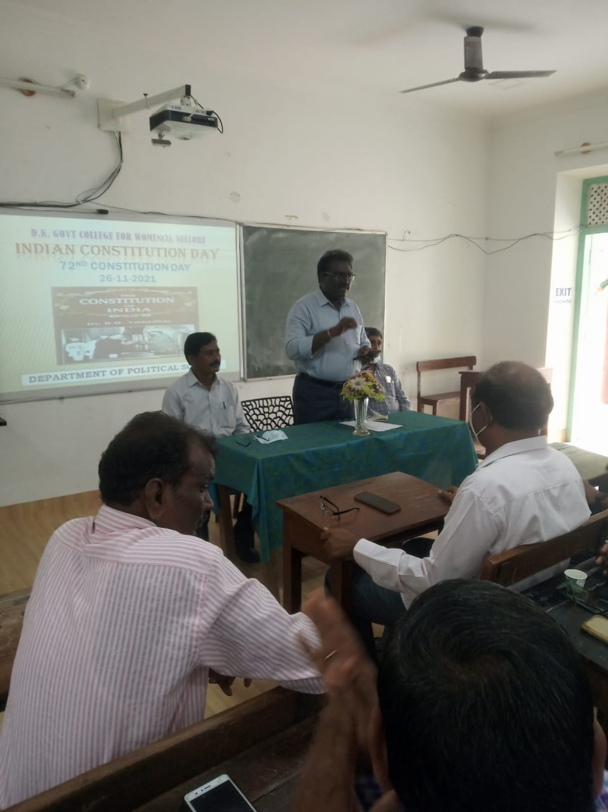

Principal of the college Dr.Giri garu addressing the Students about Indian Constitution Day
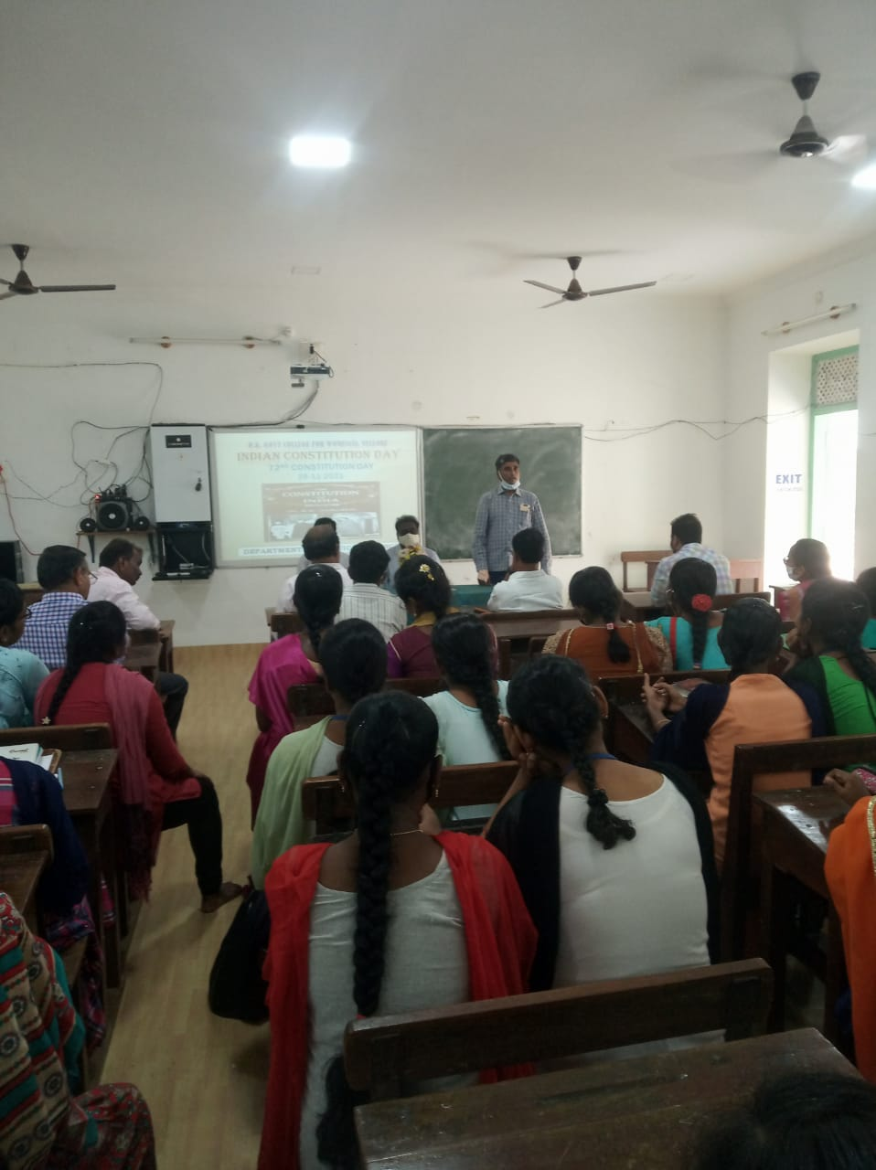

D.K. GOVERNMENT COLLEGE FOR WOMEN (A)

NELLORE

HUMAN RIGHTS DAY10-12-2021.

The Department of Political Science has organised Human Rights Day in our college on 10-12-2021.

Human Rights Day is observed every year on 10 December . The United Nations General Assembly adopted, in 1948, the Universal Declaration of Human Rights (UDHR). The UDHR is a milestone document, which proclaims the inalienable rights that everyone is entitled to as a human being - regardless of race, colour, religion, sex, language, political or other opinion, national or social origin, property, birth or other status.

The Theme for 2021 Human Rights is : EQUALITY - Reducing inequalities, advancing human rights. This programme was aimed to spread the awareness of human rights among students. The Principal of our college Dr. D. Girigaru presided over the function. The Chief guestswere Sri. Sri Mannarayana, SETNEL officer, Sri. Vijay Kumar, Voluntary organiser, Sri. A Mahendar Reddy, Nehru Yuva Kendra officer, Sri. Abdul Khayum , District skill development officer , LawerRamyarekha, Assistant Professor. D. Rama Devi participated in the program.

The speakers focussed on the rights of Human beings and enlightened the students about the right to be free from torture, the right to freedom of expression, the right to education and the right to seek asylum right to civil and political rights, such as the rights to life, liberty and privacy. One of the speaker explained that UDHR also mentions economic, social and cultural rights, such as the rights to social security, health and affordable housing. Finally it was concluded that the Universal Declaration of Human Rights sets out a broad range of fundamental rights and freedoms to which all of us are entitled. Students were very much interested and had an interactive session at the end of the program.

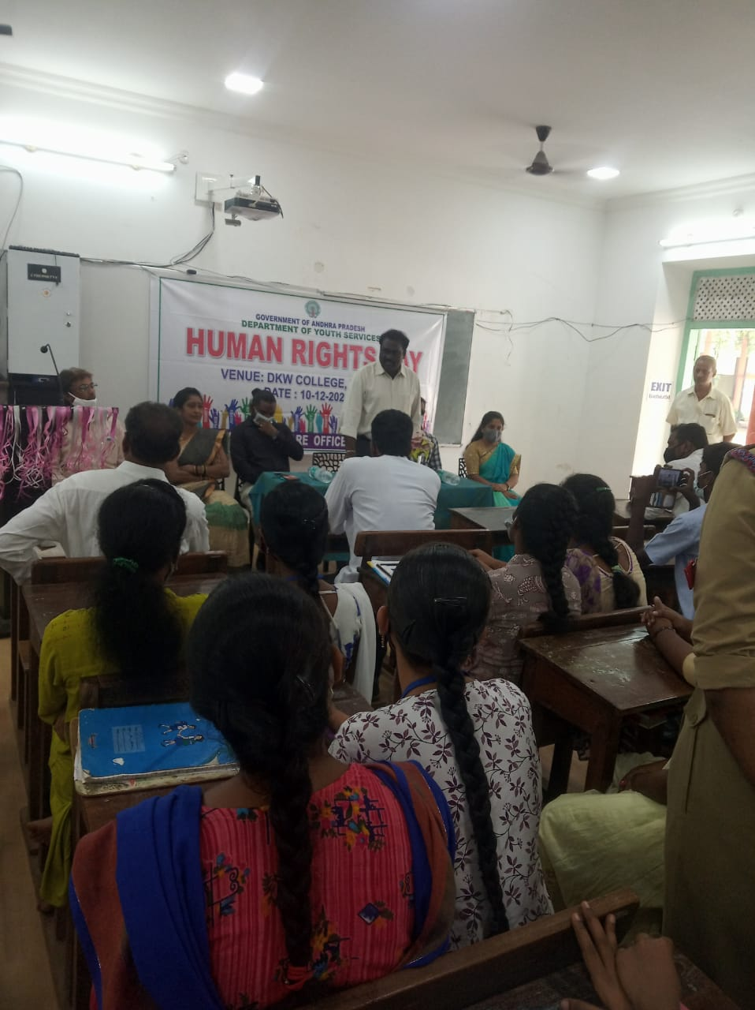

Principal of the college Dr.Giri garu addressing the Students about Human Rights Day

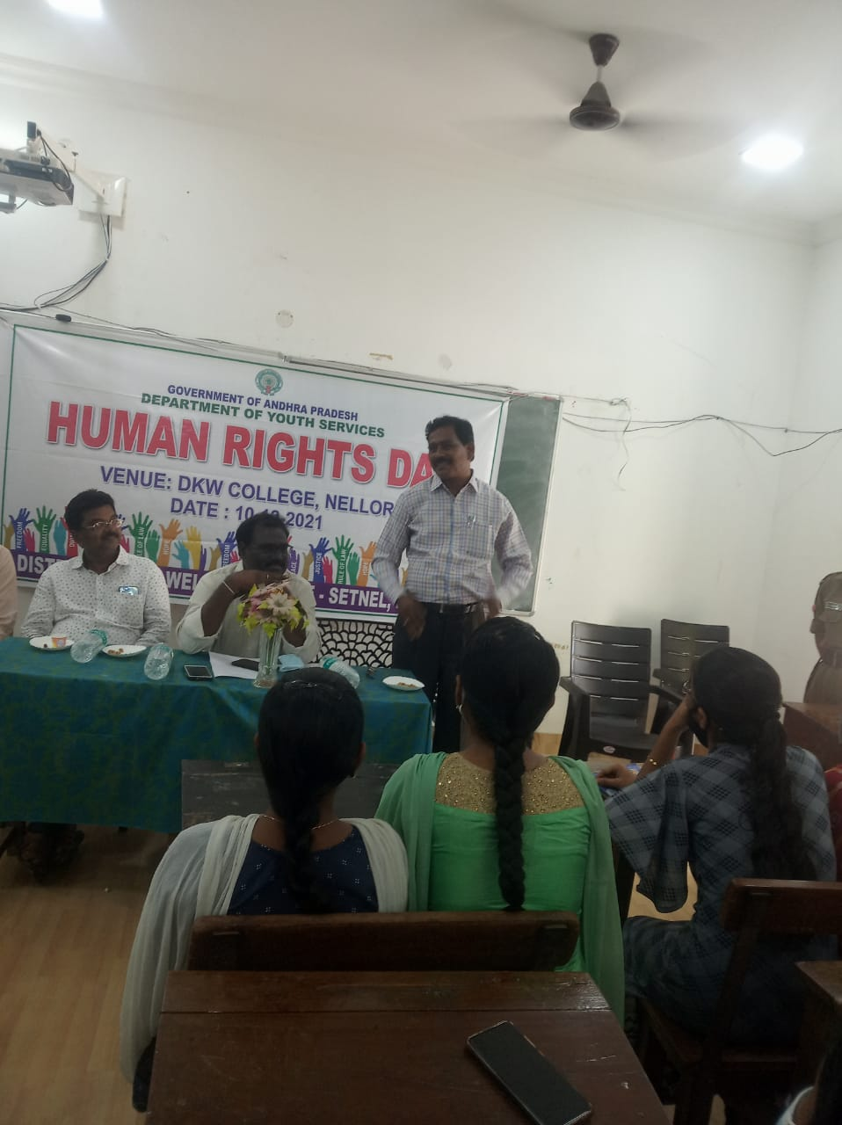

Political Science HOD Dr.K.Jojigaru interacted with the students.

The voters’ awareness day held on 25-01-2021 made the students and employees think about the value of vote and its proper utilisation. Consumers’ day held on 15-03-2021 made them think about their duties as citizens to face malpractices, adulteration, bribery, deception and illegal trading. World Environment Day held on 5-06-2020 made them think about their responsibilities to protect environment. The national anthem and national song ignited the interests of the students and reminded their role in nation building. YRC, NSS and NCC of the college train up the students to inculcate human values. The parade exhibited by the NCC cadets during Independence day and Republic day celebrations of this year inspired all and made us think about our great nation and its up keeping.

Republic Day Celebrations 2021
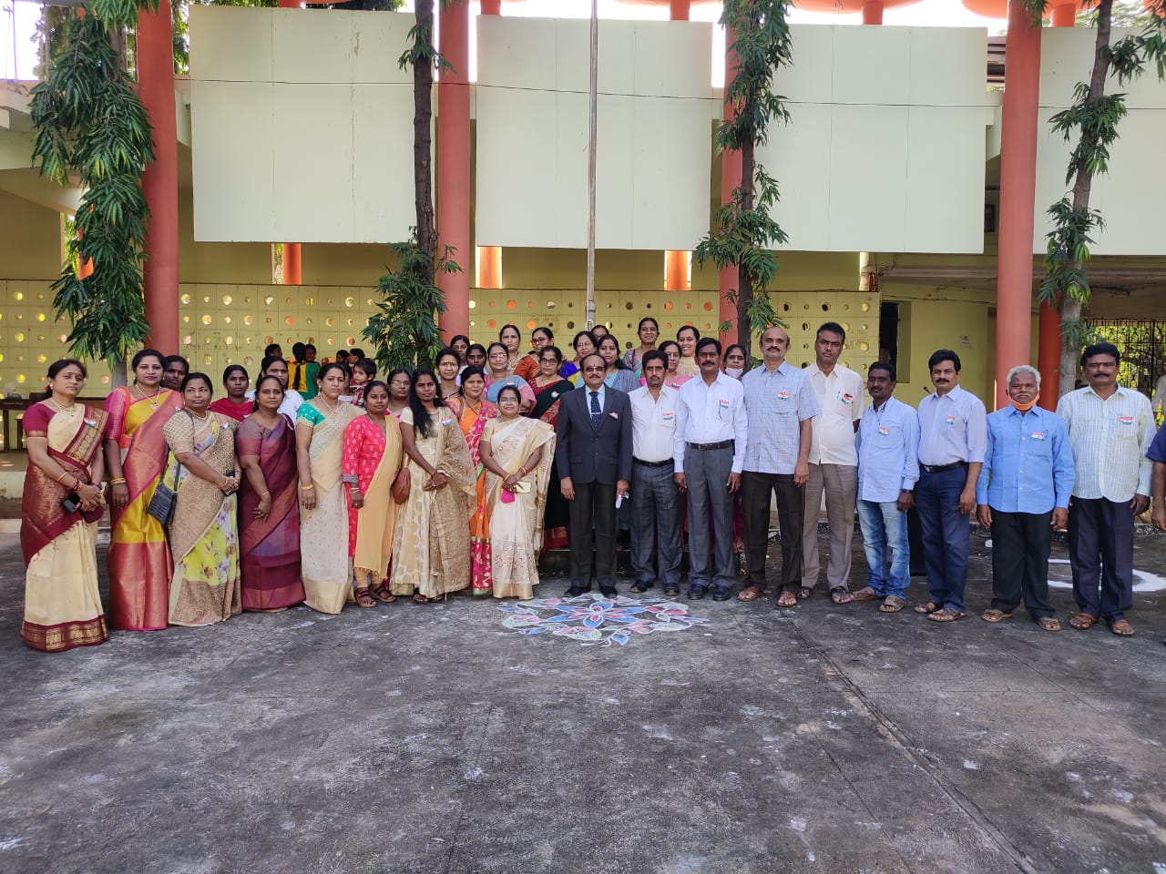

Due to pandemic Republic day celebrations in the year 2021 was done with the participation of teaching and non-teaching staff. The then Principal Dr. Ch. Masthanaiah hoisted the flag and addressed the gathering on the activities to be done to promote interest in the students on patriotism.

INDEPENDENCE DAY CELEBRATIONS – 2021
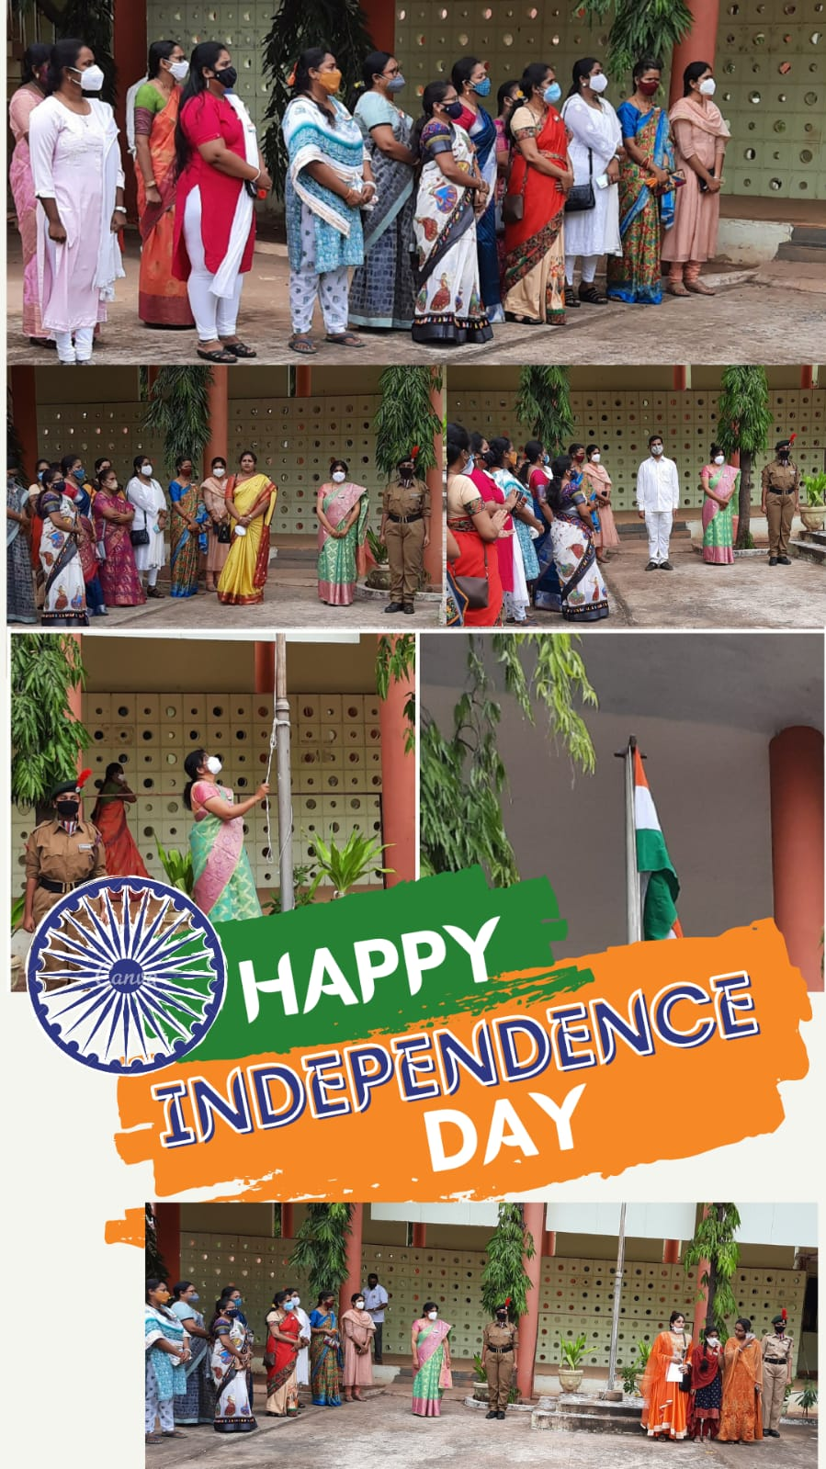
The in-charge Principal Dr. K. Karunasri hoisted the flag and gave a brief note on freedom fighters followed by the talks of the lecturers of History and Political Science. A few cultural programs were organised by the cultural department.

